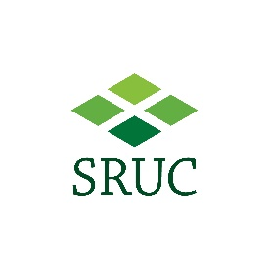

ScotPIL Poultry personal license course at SRUC
This course, if successfully passed, will enable you to apply for a Home Office personal licence (category A and B) to work with birds (domestic poultry). You should provide your address related to your place of work/study. Once you have submitted your form and paid your fee, you will be contacted prior to the course with further details.

First name:

Surname:

University/Institute address:

Email address:

Telephone number:

Fee:
For staff/students of a ScotPIL member university or institute (i.e. University of Aberdeen, Edinburgh, Glasgow, Strathclyde, Stirling, St Andrews, Dundee; Moredun Institute; SRUC): £150

For all others: £200

SRUC Finance will contact you regarding payment of fees

Admin only
Course date:
Fee:

